### **APP DEPLOY WORK FLOW SOP**

#### **Document Information**

* **Document Title: APP DEPLOY WORK FLOW**
* **Version:1.1**
* **Prepared By: App Deployment Team**

Table of Contents

APP DEPLOY WORK FLOW SOP 1

**1. Introduction** 1

1.1 Purpose of Document 1

**2. App Deploy Team Roles** 2

**3. App-Deployment Tools** 2

**4. Daily Task of App-Deployment Team** 2

**5. ServiceNow** 2

**6. Inflight Release Application** 4

**7. CloudBees Automation Deployment** 5

**7. BODT Manual Deployment** 8

**7.1. Sample BODT Migration Deployment** 8

**8. CAPI** 15

**8.1. CAPI Access** 16

**8.2. CAPI Deployment** 16

**8.2.1. CAPI Overview** 16

**8.2.2. CAPI Infra Setup** 17

**8.2.3. CAPI Administration** 18

**8.2.3. CAPI Automation** 18

9. App-Deploy Team URL’S 19

# **1. Introduction**

## **1.1 Purpose of Document**

The purpose of this document is to provide a comprehensive guide for the App Deploy Team's daily activities. It outlines detailed procedures for managing deployment updates, documenting comments, and handling STG1/2 and production deployments. The document also includes instructions for updating and managing change requests to ensure smooth deployments.

# **2. App Deploy Team Roles**

App Deploy team takes care of all the releases planned for everyday deployments plan for STG1/2, PROD, work on deployments and after every deployment team validate release version in STG1/2, PROD.

# **3. App-Deployment Tools**

* Inflight page Application
* ServiceNow
* Confluence
* Cloudbees
* Bitbucket
* BODT
* CAPI

# **4. Daily Tasks of App-Deployment Team**

* As soon as you log into your shift, you need to go through all the emails from the previous shift and check for any pending items.
* Once you've reviewed the emails, complete any pending tasks that need to be finished
* Once we receive the change request via email, we need to take the CR number and search for it in ServiceNow.
* We need to check whether the change request has been approved, i.e., in the implementation state.
* We have to look for the change plan which is updated by RM team.
* After we checked the change plan, we need to follow the change plan steps and process.
* By using Cloudbees tool, as per the change plan we need to create/use the existing release pipeline.
* We have to run pipeline according to the steps which is present in change plan part in ServiceNow.

# **5. ServiceNow**

* Once we receive the email for Release engineering team, we have to copy the Change request number and search it in ServiceNow
* We have to look for Assignment group, if it is assigned to App-Deploy, we have to verify weather CR is in implementation stage or not.
* If CR is in implementation stage, we have to look for Change plan
* We have to follow the steps which is mentioned in the Change plan by Release engineering Team
* Below image shows the Change plan in Snow.

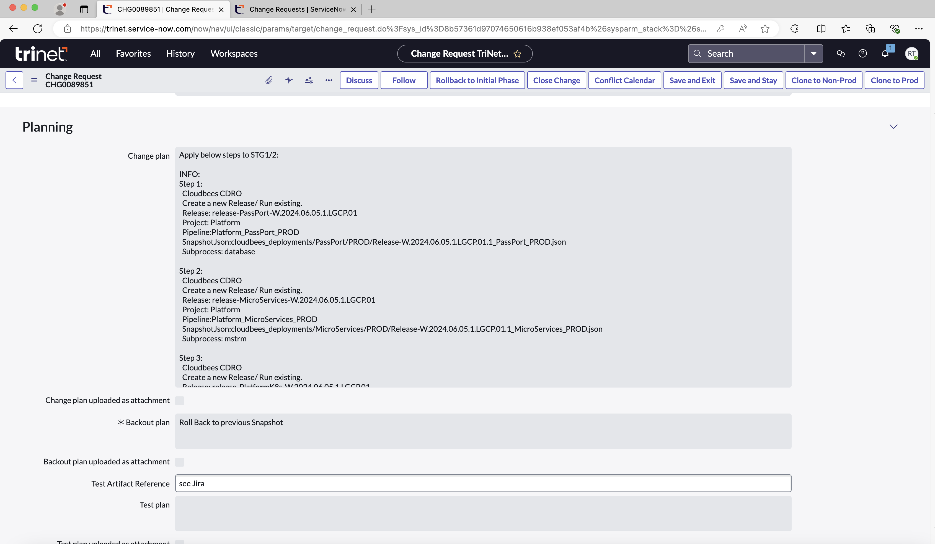

* Once the Deployment is completed successfully, we have to assign the CR to ourselves and we have to update work notes. Example: Applied to STG1/2, PROD.
* The below image states that Application Deployment Dashboard which includes number of deployments and tasks planed for particular day for Prod and Non-Prod.

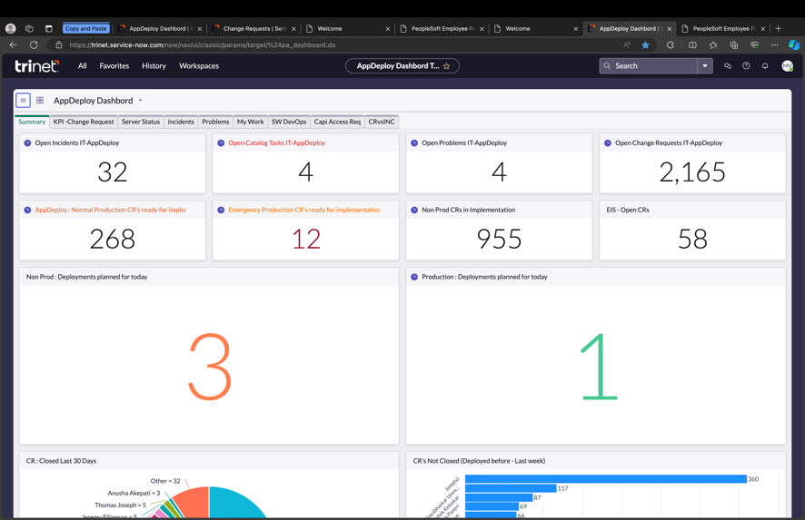

# **6. Inflight Release Application**

Overview

* Inflight release application is an internal tool used to manage the current releases. This replaces the [confluence page](https://confluence.trinet-devops.com/pages/viewpage.action?spaceKey=RM1&title=Inflight+and+Upcoming+off+cycle+Releases) currently used by the agile teams. This user document explains how to use this application.
* Application URL
* <https://inflight.engtools01.trinet.internal/view/>
* Main Menu
* After you land on the inflight page you can click on the hamburger menu on the top left side of the page to expand the menu options.

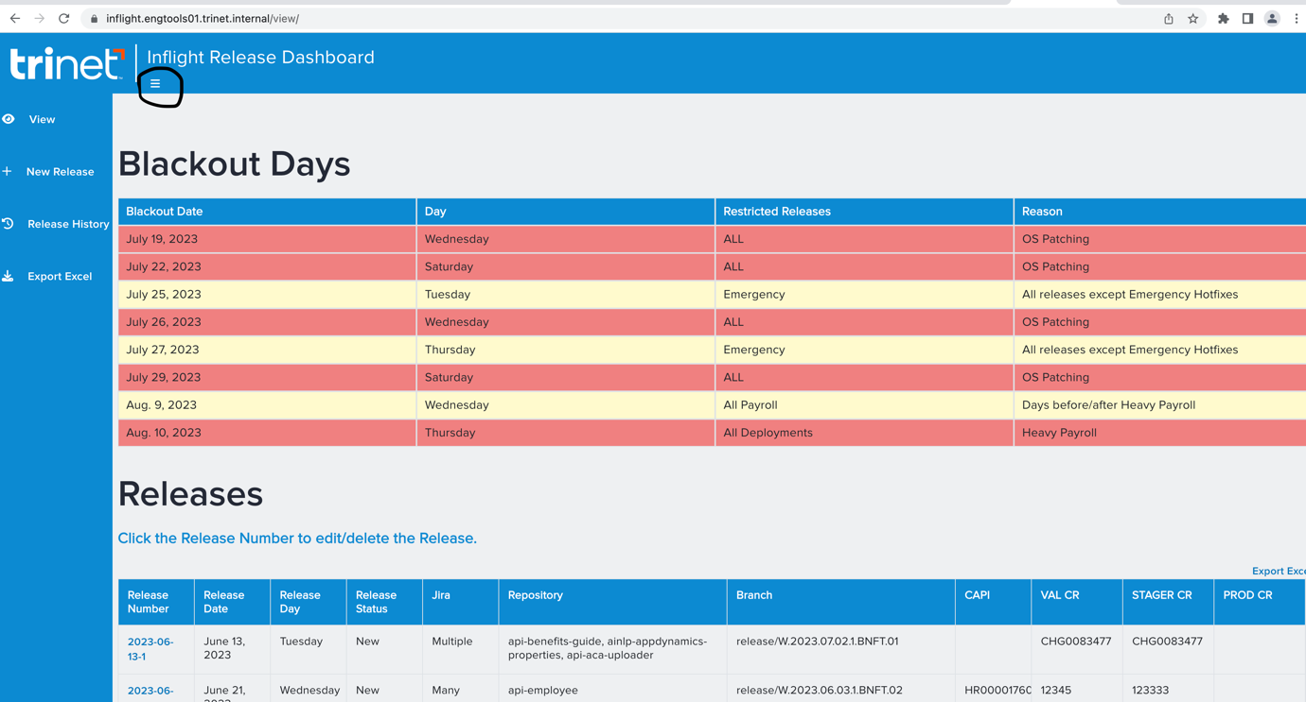

# **7. CloudBees Automation Deployment**

* Once we got the change plan from Snow, we have to create/use the existing release pipeline as shown below image.

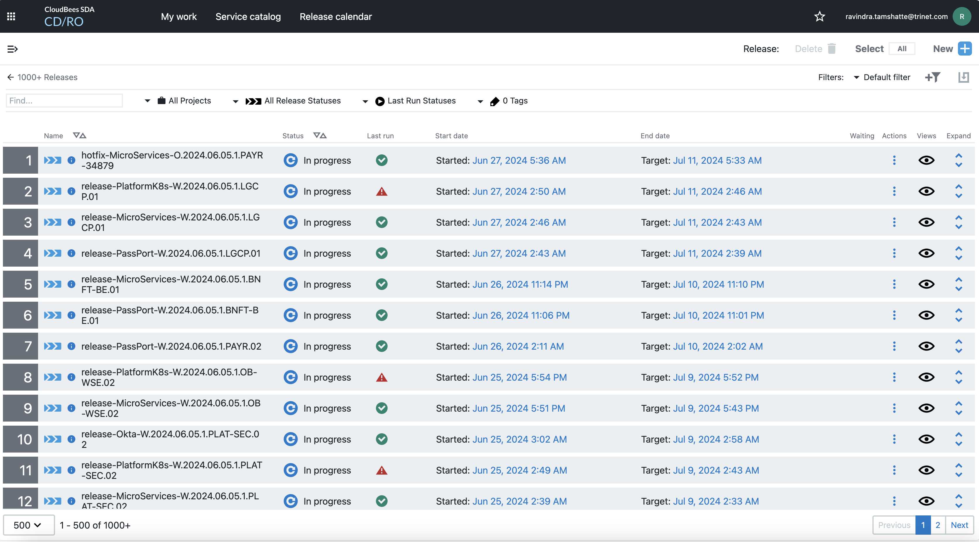

* To create a release pipeline we have to select the release name, Project, Pipeline which is mentioned in the change plan.
* Below image show the Creation Release in CB

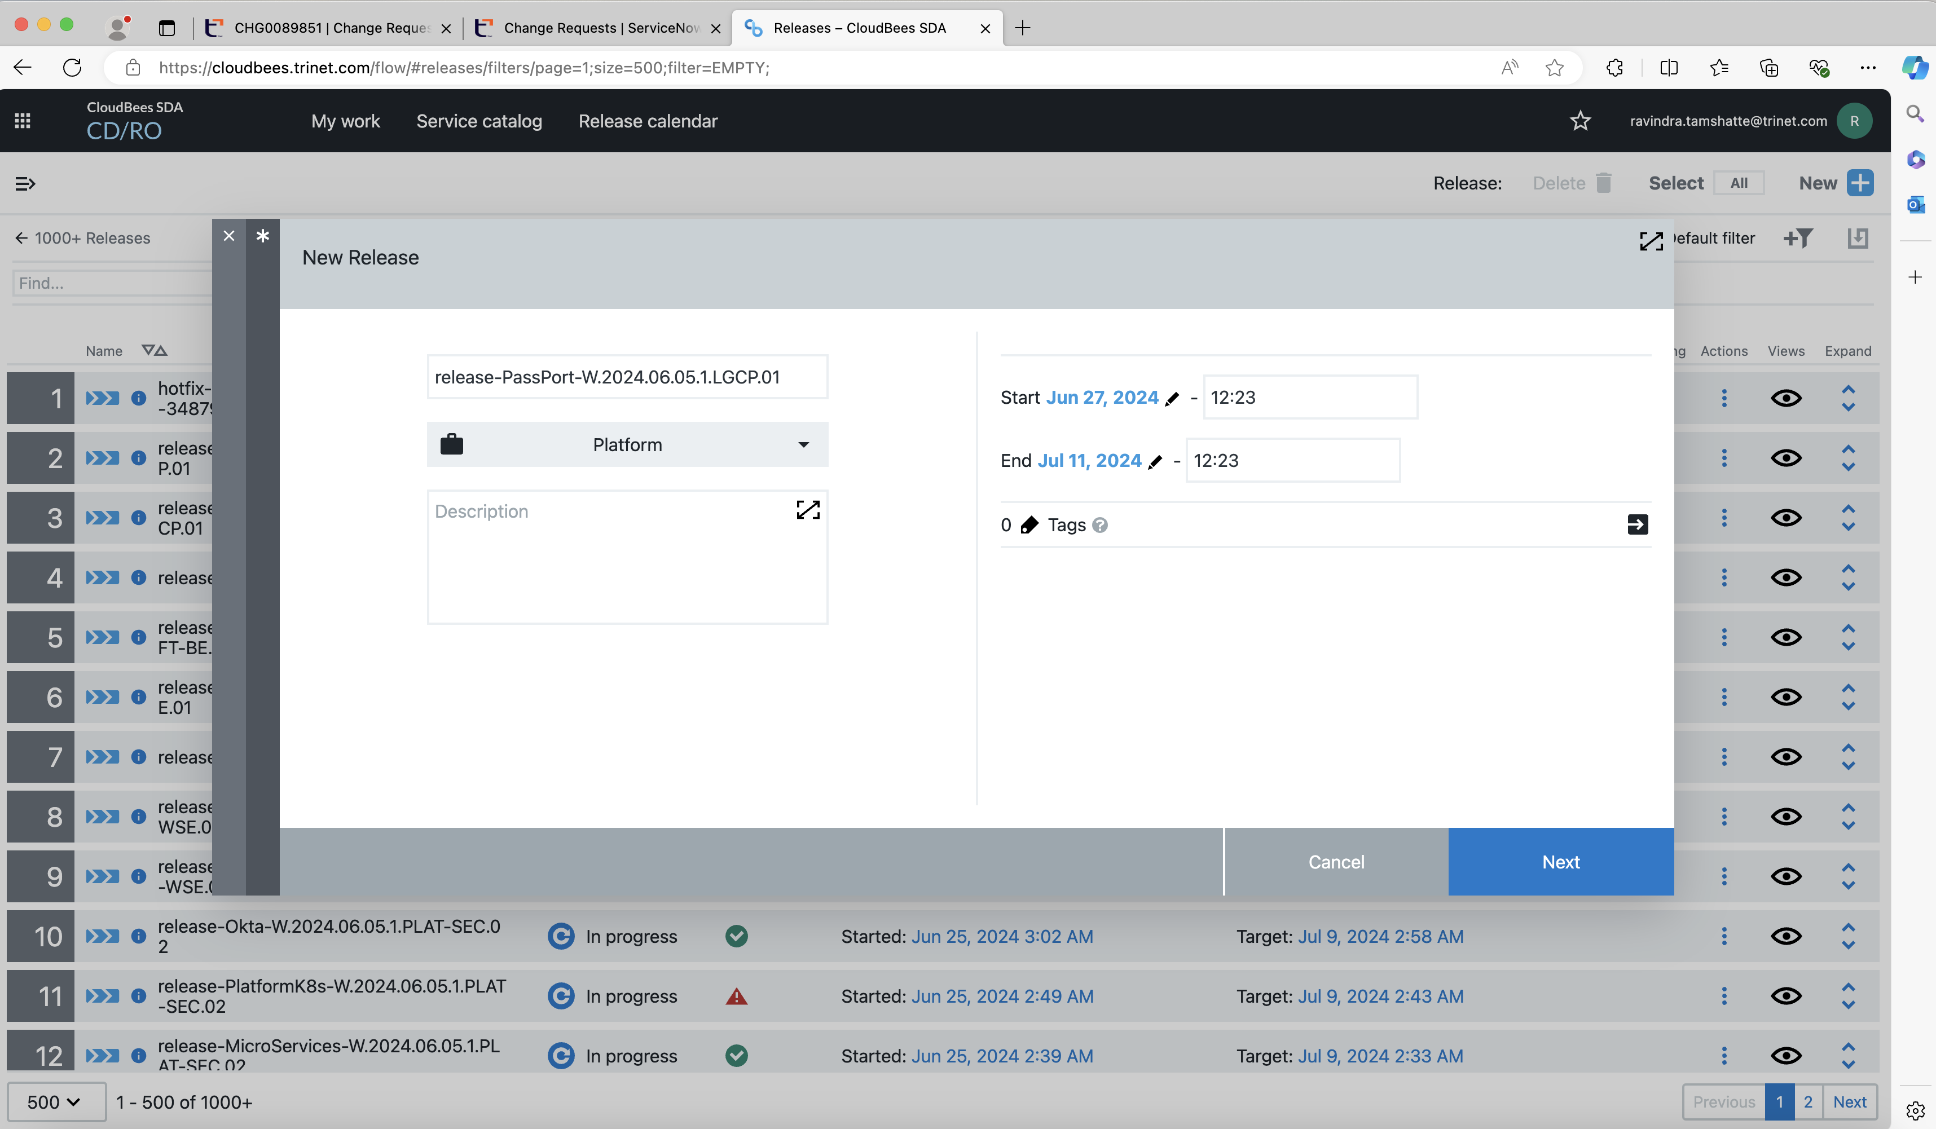

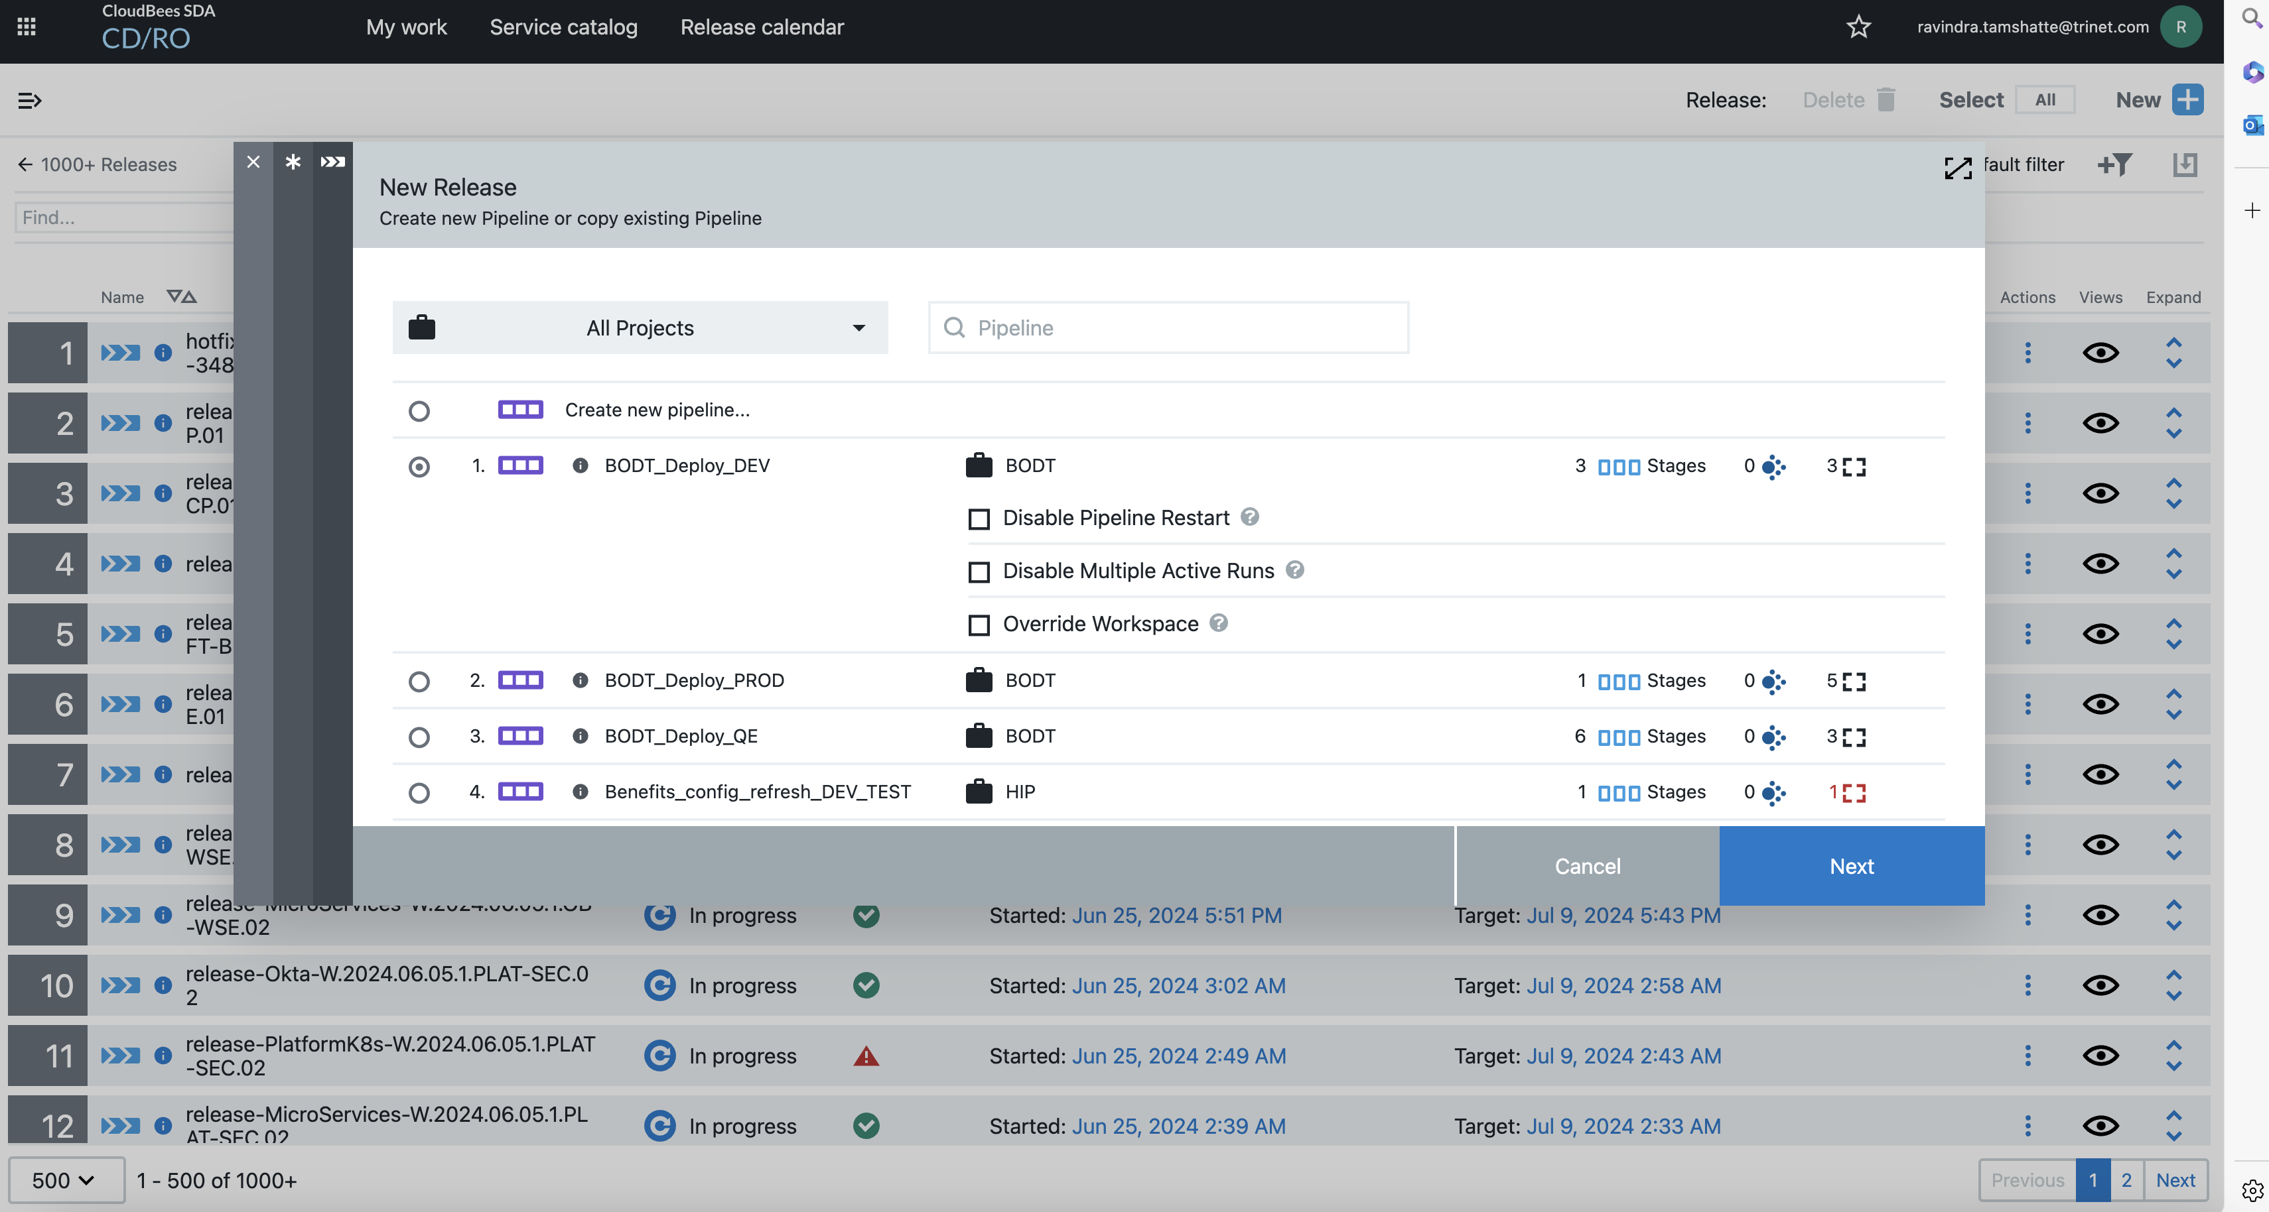

* Once release pipeline is created, we need to select and run the pipeline for the particular environment which is mentioned in the Change plan.
* we have to select the process which is mentioned in Change plan.
* Also we have to give snapshot and CR number which is also mentioned in Change plan
* Below image shows the above mentioned points.

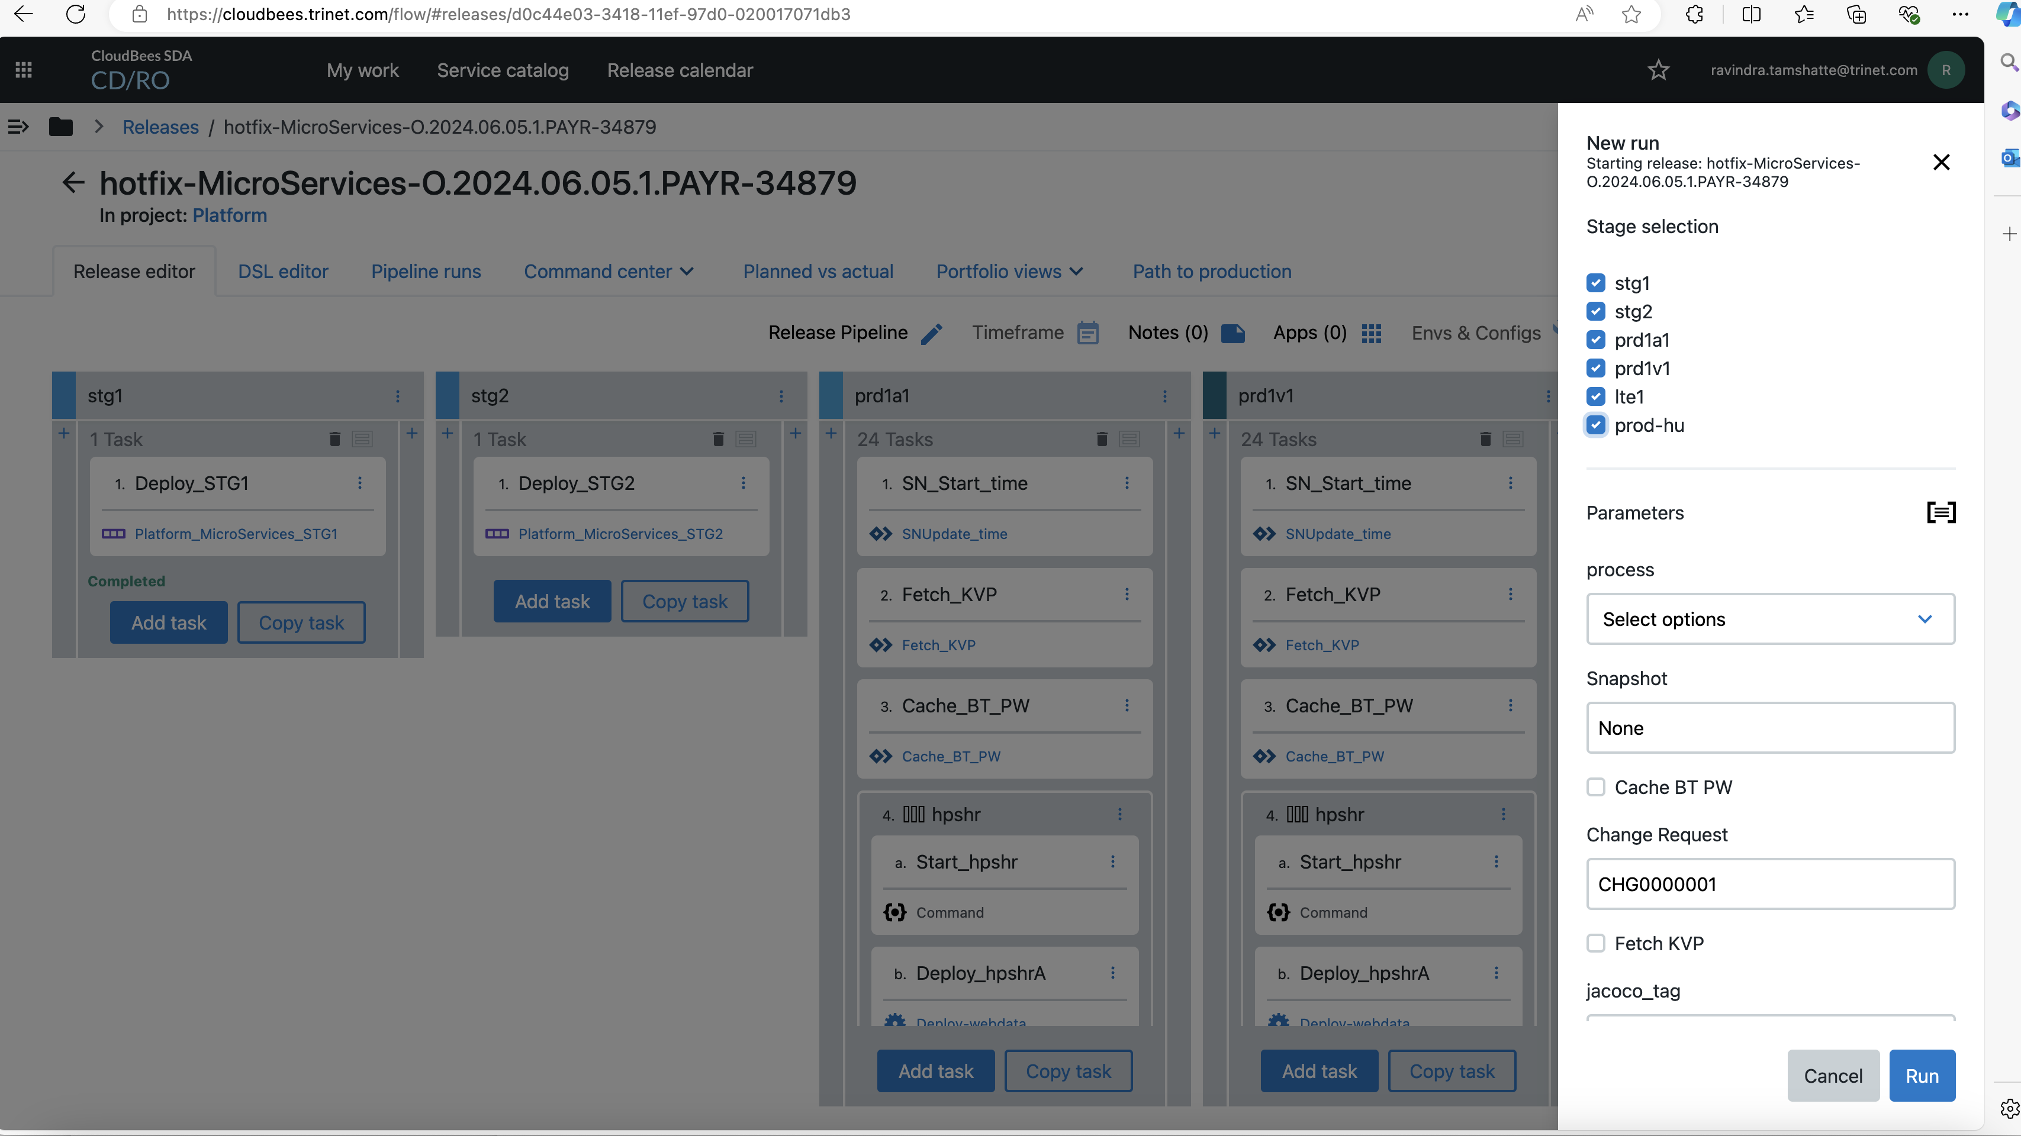

* Once we have given all the required inputs which is required to run pipeline. we have to trigger the pipeline using Run option.

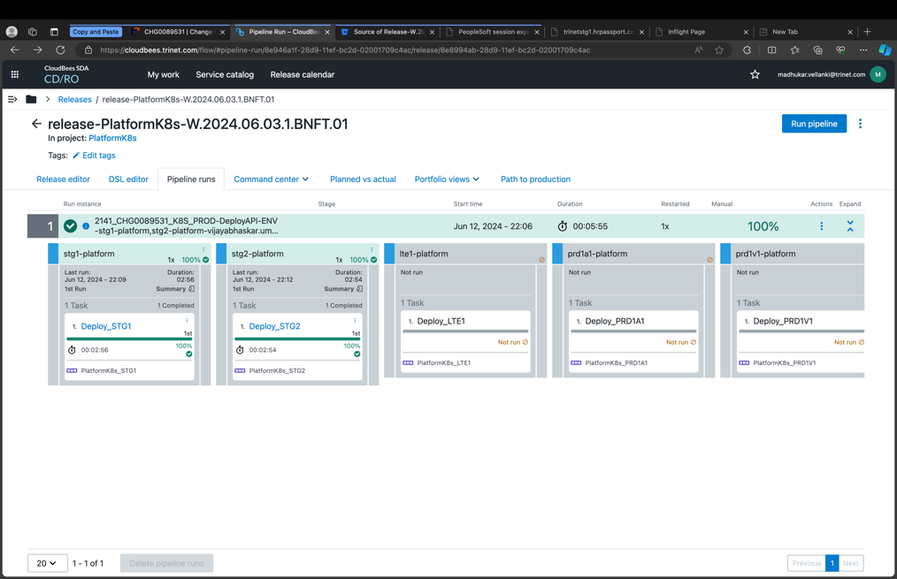

# **7. BODT Manual Deployment**

* BODT – Back office digital transformation can also be called as oracle fusion
* We have two types of objects in BODT

1. Data Object – ends with extension xdoz
2. Data Model – ends with extension xdmz

* For BODT deployments we are not adding any entry in the inflight release dashboard like PEO application
* We do BODT automated deployments using cloudbees
* ADA team is in the process of automating all the manual deployments.

# **7.1. Sample BODT Migration Deployment**

**Migration**

Log into Dev7 environment

<https://login-etgw-dev7-saasfaprod1.fa.ocs.oraclecloud.com/>

Log into Bi publisher.

<https://login-etgw-dev7-saasfaprod1.fa.ocs.oraclecloud.com/analytics>

Navigate to below mentioned path.

**Shared/Custom/Human Capital Management/Recruiting/Reports/Offer_Report.xdo**

Download below file on your desktop



Once you download go to below path

**1)Shared/Custom/Human Capital Management/Recruiting/Reports/Data Model**

Click on unarchive as shown below (highlighted in yellow)

It will replace automatically

Click on browse and select the Offer_Report_DM.xdm.catalog file which you have downloaded above

**Keep Replace : OLD , ACL : Preserve**

Click on ok

You willl find the Data Model Loaded report loaded , click on edit (highlighted in yellow)

Click on the search icon as shown below



2) **Shared/Custom/Human Capital Management/Recruiting/Reports**



You willl find the report loaded , click on edit (highlighted in yellow)

Click on Edit in Offer_report as below

Click on Search button and add below data model

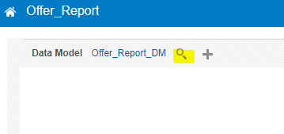

**Search Offer_Report_DM from below path**

**Shared/Custom/Human Capital Management/Recruiting/Reports/Data Model**

**And select Offer_Report_DM and click on Ok**

**Once add Data Model report should be like below**

**And click on Save**

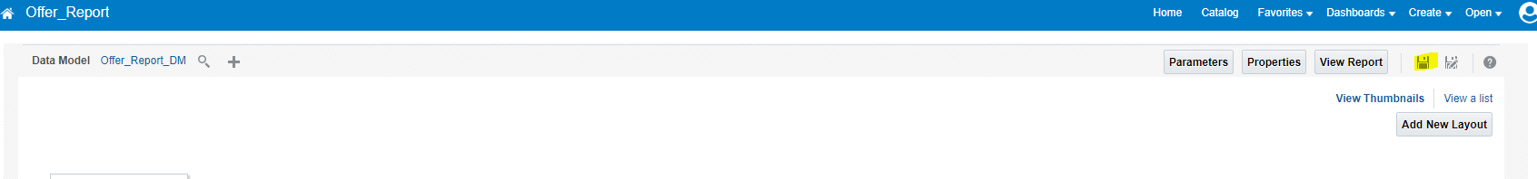

# **8. CAPI**

* We are doing two types of tasks in CAPI

1. CAPI Access
2. CAPI Deployments

# **8.1. CAPI Access**

* We are getting CAPI Access request in Snow using the oracle admin dashboard we have to give access
* CAPI URL: [PeopleSoft Employee Portal (trinet.com)](https://capiprod.trinet.com/psp/capi/EMPLOYEE/PT_LOCAL/h/?tab=DEFAULT)

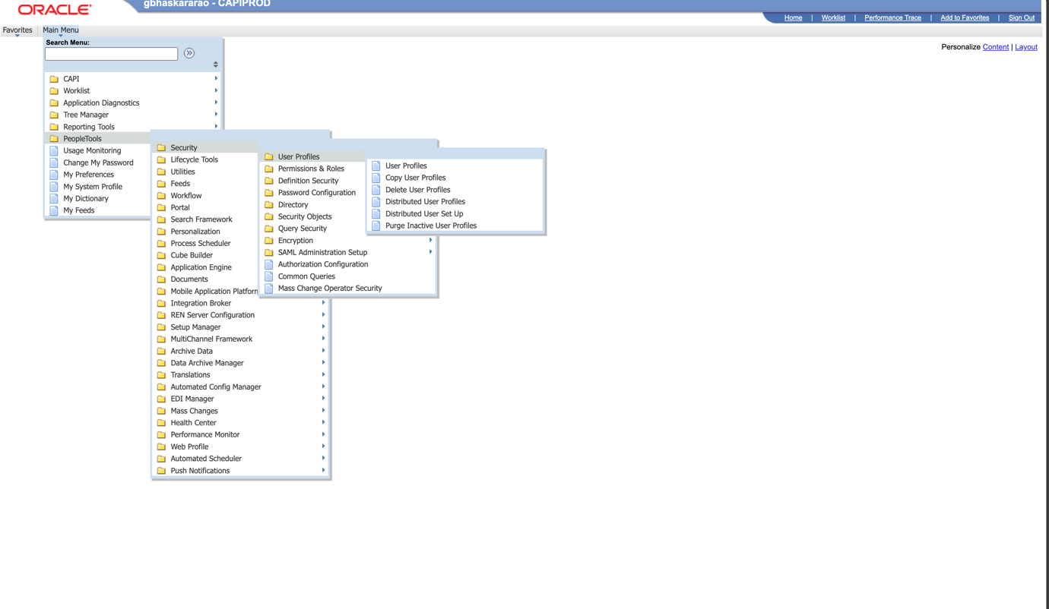

# **8.2. CAPI Deployment**

# **8.2.1. CAPI Overview**

* CAPI is the tool built on people tools, primarily used for migration of PeopleSoft codes (db, file objects) to the various env.
* Source to target.
* Dev
* CAPI CR
* Below are the images of CAPI Manual Deployment
* 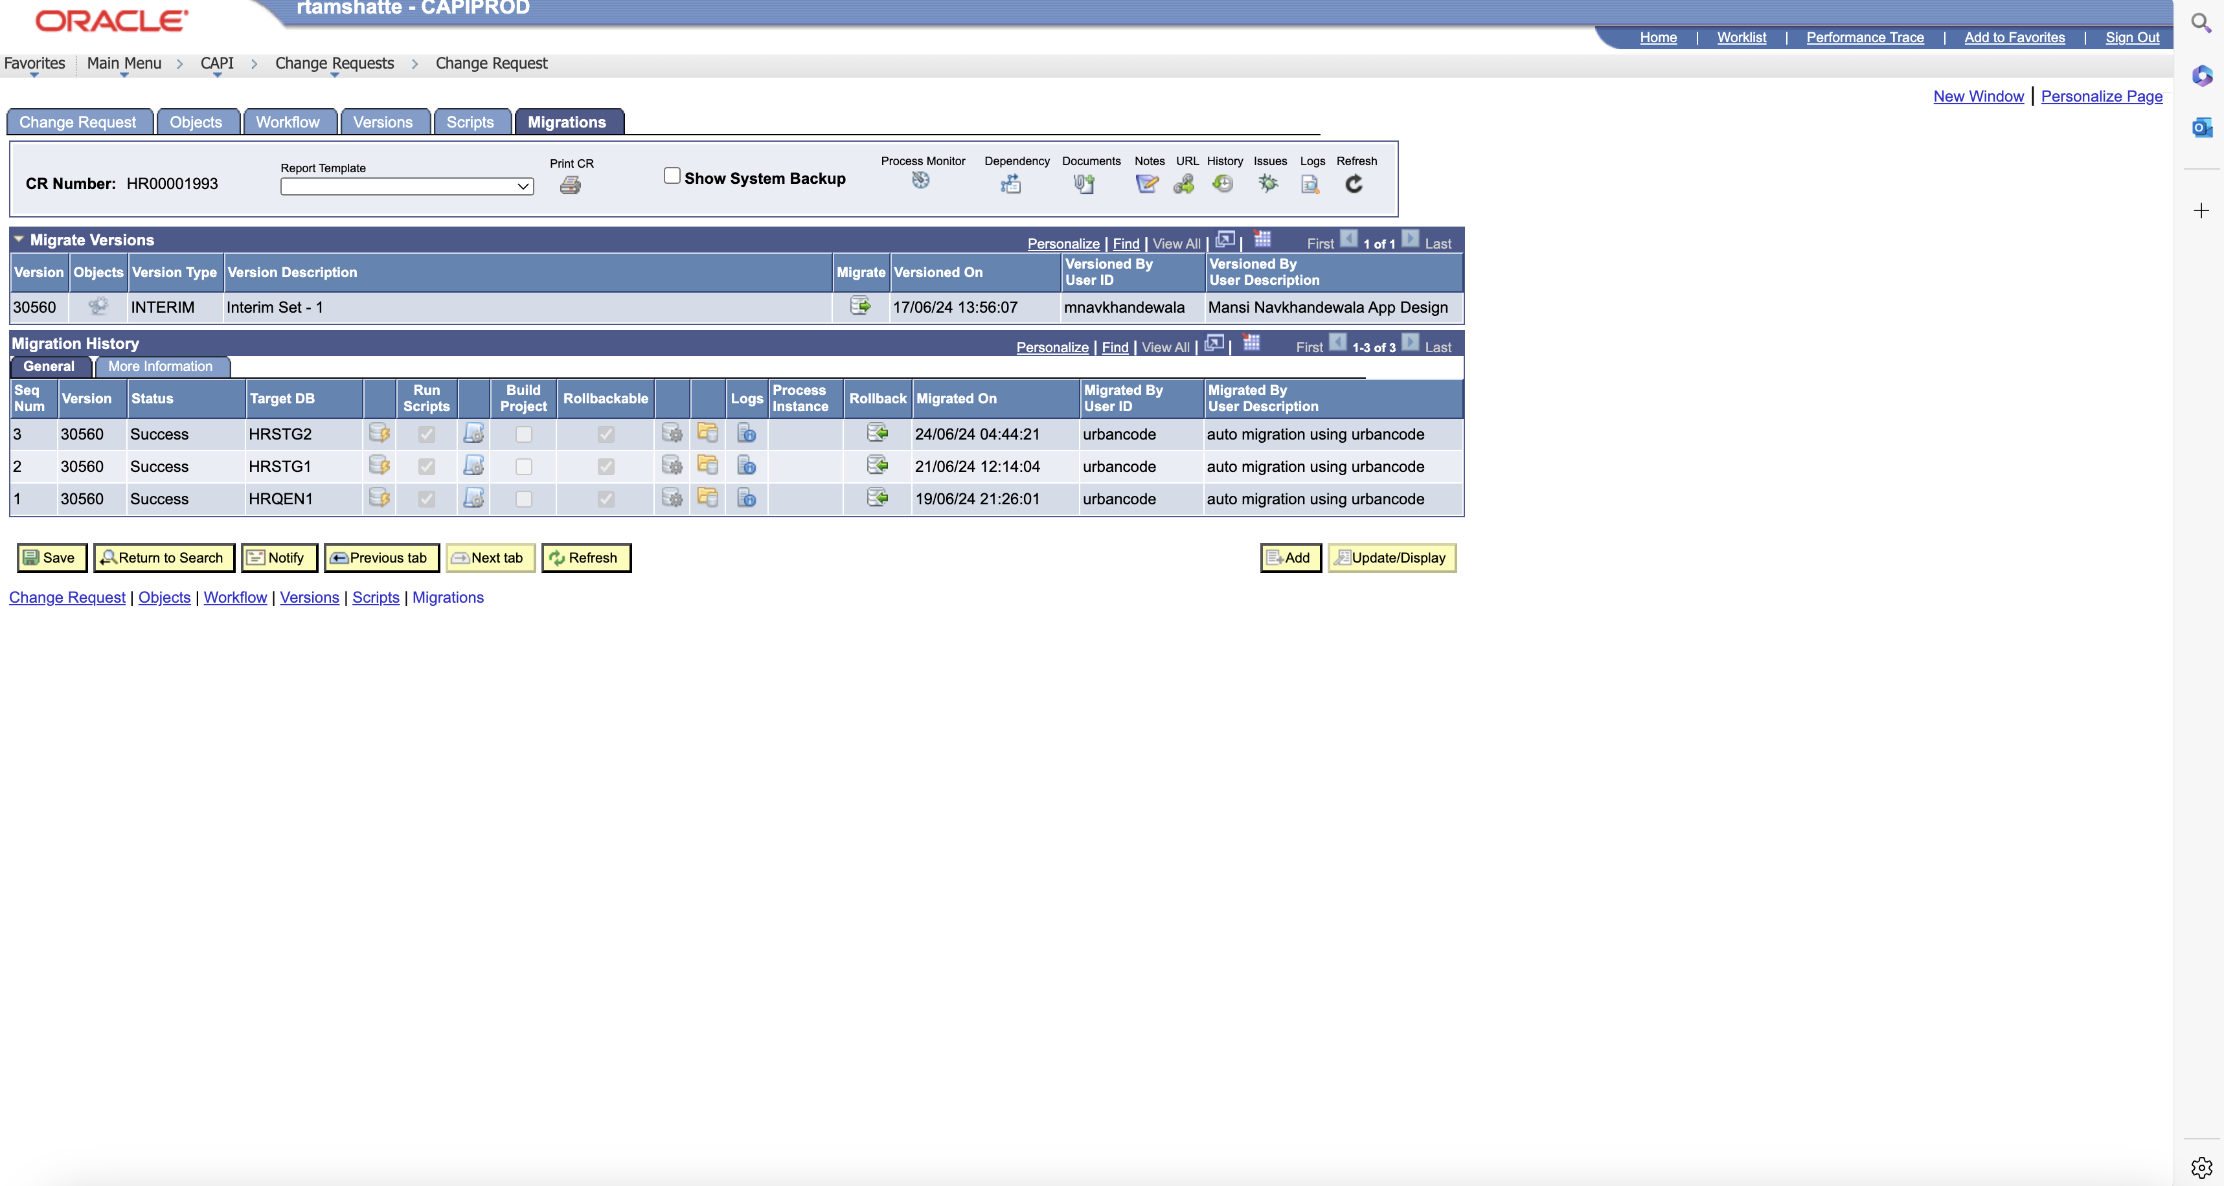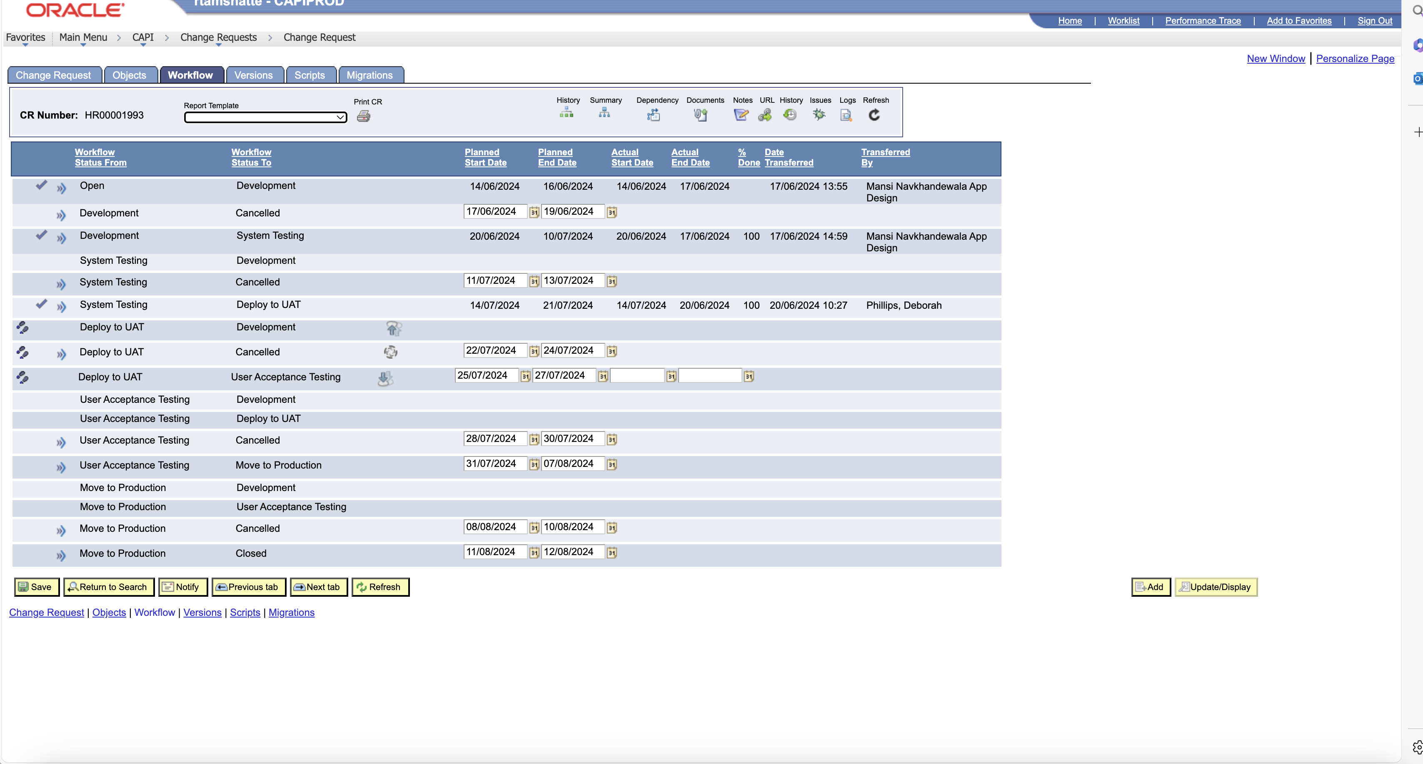

# **8.2.2. CAPI Infra Setup**

* DEV - Just the CAPI dev env.
* PROD - Main env used by everyone.
  1. pa1cpweb1/2
  2. pa1cpapp1/2
  3. user - capi

# **8.2.3. CAPI Administration**

* + CAPI Start/stop - SRE, [CAPI Stop & Start Procedures](https://confluence.trinet-devops.com/pages/viewpage.action?pageId=67681915)
  + CAPI Workflow - [03 Correct the CAPI workflow](https://confluence.trinet-devops.com/display/ADT/03+Correct+the+CAPI+workflow)
  + New Env Setup - [001 Configure New Environment in CAPI](https://confluence.trinet-devops.com/display/ADT/001+Configure+New+Environment+in+CAPI)
  + Lock/unlock objects
  + User Account admin - Lock, unlock, release
  + CAPI Role/Permission
  + Rapid Recovery - Super users only can run this for any environment.

# **8.2.3. CAPI Automation**

* Java Utility
* java -classpath . -Dlog4j.configuration=file:log4.properties -jar ./capi.jar -action migrate -crnumber HR00000047 -version 143 -username cloudbees -password ########## -database HRQEN1
* Below are the image for CAPI automation deployment

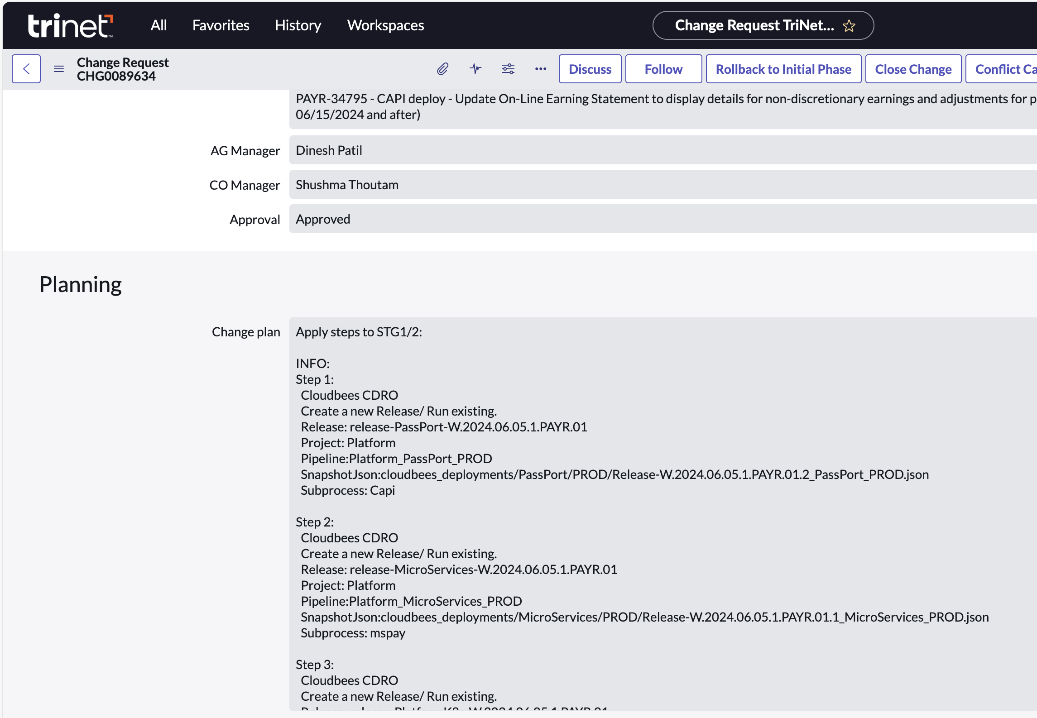

## **9. App-Deploy Team URL’S**

DL: IT-ApplicationDeployment@trinet.com

ServiceNow DashBoard: [AppDeploy Dashbord | ServiceNow TriNet (service-now.com)](https://trinet.service-now.com/now/nav/ui/classic/params/target/%24pa_dashboard.do%3Fsysparm_dashboard%3D404c9cc51b6fc0d4453b98aebd4bcbeb)

Inflight page: [Inflight Page (trinet.internal)](https://inflight.engtools01.trinet.internal/view/)

Cloudbees : [Releases – CloudBees SDA (trinet.com)](https://cloudbees.trinet.com/flow/#releases)

BODT Dev7: [Welcome (oraclecloud.com)](https://fa-etgw-dev7-saasfaprod1.fa.ocs.oraclecloud.com/fscmUI/faces/AtkHomePageWelcome?_adf.ctrl-state=1849xgk6i8_1&_adf.no-new-window-redirect=true&_adf.no-new-window-redirect=true&_adf.no-new-window-redirect=true&_afrLoop=96888124992116191&_afrWindowMode=2&_afrWindowId=null&_afrFS=16&_afrMT=screen&_afrMFW=1680&_afrMFH=924&_afrMFDW=1728&_afrMFDH=1117&_afrMFC=10&_afrMFCI=0&_afrMFM=0&_afrMFR=192&_afrMFG=0&_afrMFS=0&_afrMFO=0)

BODT Dev19: [Welcome (oraclecloud.com)](https://fa-etgw-dev19-saasfaprod1.fa.ocs.oraclecloud.com/fscmUI/faces/AtkHomePageWelcome?_adf.ctrl-state=9ox97smt2_1&_adf.no-new-window-redirect=true&_adf.no-new-window-redirect=true&_adf.no-new-window-redirect=true&_adf.no-new-window-redirect=true&_afrLoop=27317908177654152&_afrWindowMode=2&_afrWindowId=q859h2zom&_afrFS=16&_afrMT=screen&_afrMFW=1680&_afrMFH=924&_afrMFDW=1728&_afrMFDH=1117&_afrMFC=10&_afrMFCI=0&_afrMFM=0&_afrMFR=192&_afrMFG=0&_afrMFS=0&_afrMFO=0)

BODT PROD: [Welcome (oraclecloud.com)](https://fa-etgw-saasfaprod1.fa.ocs.oraclecloud.com/fscmUI/faces/AtkHomePageWelcome?_adf.ctrl-state=gg9drw02m_1&_adf.no-new-window-redirect=true&_adf.no-new-window-redirect=true&_afrLoop=58775280699607184&_afrWindowMode=2&_afrWindowId=null&_afrFS=16&_afrMT=screen&_afrMFW=1680&_afrMFH=924&_afrMFDW=1728&_afrMFDH=1117&_afrMFC=10&_afrMFCI=0&_afrMFM=0&_afrMFR=192&_afrMFG=0&_afrMFS=0&_afrMFO=0)

CAPI: [PeopleSoft Employee Portal (trinet.com)](https://capiprod.trinet.com/psp/capi/EMPLOYEE/PT_LOCAL/h/?tab=DEFAULT)

MyAccess: [MyAccess - Access Requests (trinet.com)](https://myaccess.trinet.com/identityiq/identityRequest/identityRequest.jsf)

Confluence: [AppDeploy Team - IT App Admin Team - Confluence (trinet-devops.com)](https://confluence.trinet-devops.com/display/prodready/AppDeploy+Team)